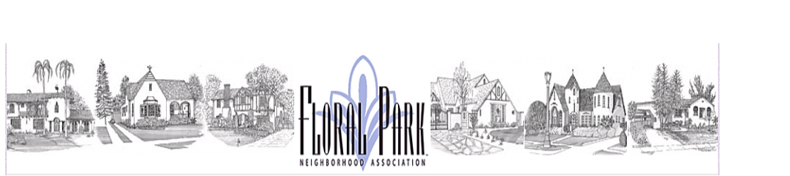

**Monthly Board Meeting Agenda:**

**FPNA Board Meeting**

**Tuesday, January 14, 2025 - 7:00 pm to 8:30 pm**

**Chris Switzer’s Home – 2462 N. Riverside Dr.**

**Board of Directors**

President □ Craig Kalthoff-Patti

FirstVice President (Sponsorships) □ Stephanie Miles

Co-Second Vice President (Beautification) □ Chris Switzer

Co-Second Vice President (Beautification) □ Beth Hoffman

Secretary □ Britiny Cecil

Treasurer □ Peter Christoffersen

Parliamentarian □ Julie Humphreys

Co-Communications Director □ Jessica Carr

Co-Communications Director □ Mason Nakamura

Social Director □ Allyson Thompson

Co-Membership Director □ Kevin Shuler

Co-Membership Director □ Chris Rosas

**A: Call to Order, Regular Board Meeting**

**B: Approve November 2024, Board Meeting Minutes**

**C. Public Comments: 3 minutes per neighbor and Secretary to read any received correspondence**

**D. No Board Reports for December 2024: Individual Director comments per Board Group for any updates/issues**

**Old Business**

|  |  |  |  |  |
| --- | --- | --- | --- | --- |
|  | **Discussion Topics** | **Presenter** | **Alloted Time** | **Notes** |
| 1. | Meeting with PW Director Nabil Saba January 13th  Meeting | Craig | 5 min | 1. Historical Monuments Timeline. Financial eye out 2. Jefferson/18th Curb repair and street lamp installation |
| 2 | Traffic Informational Meeting | Craig | 5 min | Send out e-blast to solicit volunteer interest. If no interest, subject tabled |
| 3 | Assistance League General Meetings 2025 |  | 5 min | 3/13, 6/12, 9/11, 11/13 confirmed |
| 4 | Storage Update | Peter | 5 min |  |

**New Business**

|  |  |  |  |  |  |  |  |  |
| --- | --- | --- | --- | --- | --- | --- | --- | --- |
|  | **Discussion Topics** | | | **Presenter** | | **Alloted Time** | | **Notes** |
| 1. | Standing Rules, Bylaws, Legacy Award | | | Julie | | 15 min | | Changes Proposed |
| 2. | Sponsorship Guidelines Update | | | Stephanie | | 10 min | | Update special project grant, charity nomination |
| 3 | FP Night Out and Other Events | | | Group | | 5 min | | Board Approval process.  Self funded vs sponsored |
|  | **Discussion Topics** | | | **Presenter** | | **Alloted Time** | | **Notes** |
|  |  | | |  | |  | |  |
| 4 | Treasurers Report | | | Peter | | 10 min | | 2024 year end results; Motion to approve November/December 2024 reports; 2025 Budgets distributed so planning can occur |
| 5. | USPS Bulk Mailing permit | | | Peter | | 5 min | | Is this planned to be used by Home Tour $275 |
| 6 | | Membership Provider, Giving Fuel | Peter, Kevin, Chris | | 5 min | | Opportunity to take advantage of additional programs | |
| 7. | | New FP Website  Member Donation |  | |  | | Membership Donation Section Change | |
| 8. | | Proposed Social Director Redesign | Craig, Group | | 15 min | | Summer 2025 | |
| 9. | | Floral Park Google Calendar Revival | Jess | | 5 min | |  | |
| 10. | | Gazette Discussion | Jess, Group | | 15min | |  | |