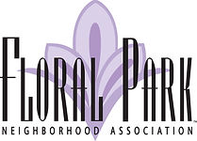
2025 Volunteerism Award Application – High School Application
DUE MARCH 7th 2025
Open to graduating seniors of the Santa Ana Unified School District (including Santa Ana public charter schools), who also live in Santa Ana. Applications will be judged on this application and essay only.

Student Name:
Home Address
Street: City: Santa Ana (must be in SA) State: CA Zip:
Phone Number:
Email:
Date of Application:
High School Name:
- List School Activities:

2. List Community Involvement (including church, charities, volunteer work, etc.) and number of hours in each activity.

3. Essay Portion
Please describe in 500 words or less (about 1 single-spaced page) your most meaningful volunteer or unpaid service experience and how it impacted your life.

School Counselor Name:
School Counselor Email:
School Counselor Phone Number:
Post High School Educational Plans:

Applications will be judged on this application and essay only.

This form must be submitted emailed or postmarked by March 7, 2025.
via email to giving@floralpark.com
or via mail at:
FPNA Neighborhood Scholarship Award
P.O. Box 11366, Santa Ana, CA 92711-1366

