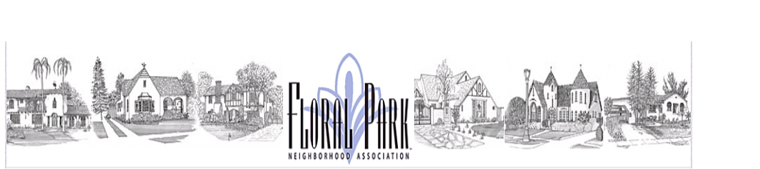

**Monthly Board Meeting Agenda:**

**FPNA Board Meeting**

**Tuesday, November 12, 2024 - 7:00 pm to 8:00 pm**

**2006 Victoria Dr. (Angel Barnes Home)**

**Board of Directors**

President □ Craig Kalthoff-Patti

FirstVice President (Sponsorships) □ Stephanie Miles

Co-Second Vice President (Beautification) □ Chris Switzer

Co-Second Vice President (Beautification) □ Beth Hoffman

Secretary □ Britiny Cecil

Treasurer □ Peter Christoffersen

Parliamentarian □ Julie Humphreys

Co-Communications Director □ Jessica Carr

Co-Communications Director □ Mason Nakamura

Social Director □ Allyson Thompson

Co-Membership Director □ Kevin Shuler

Co-Membership Director □ Chris Rosas

Home Tour Director □ Sandy DeAngelis

**A: Call to Order, Regular Meeting**

**B: Approve October 2024 Board Meeting Minutes**

**C: Public Comments: 3 minutes per neighbor and Secretary to read any received correspondence**

**D: Board Reports Review and Comments: Board Group**

**Old Business**

|  |  |  |  |  |
| --- | --- | --- | --- | --- |
|  | **Discussion Topics** | **Topic Leader** | **Time** | **Notes** |
|  |  |  |  |  |
| 1. | Santa Ana HS/Rose Parade Cancellation | Peter | 5 min | Discussed 2K Donation |
| 2. | Care & Compassion Committee | Craig | 2 min | On Hold Until June 2025 |
| 3. | Storage Unit Clean-Out/Arrange | Group | 10 min | How To Discussion |
|  |  |  |  |  |
| 4. | Jefferson and 18th Streetlights | Craig | 5 min | Public Works meeting being arranged |
| 5. | Historical Monuments Timeline | Craig | 5min | Review Timeline |
| 6. | Legacy Committee Update | Sandy | 5 min |  |
|  |  |  |  |  |

**New Business**

|  |  |  |  |  |
| --- | --- | --- | --- | --- |
|  | **Discussion Topics** | **Topic Leader** | **Time** | **Notes** |
| 1. | Traffic Committee Informational Meeting | Craig | 5 min | Present at General Mtg 11/12 |
| 2. | |  |  |  |  | | --- | --- | --- | --- | | Committee Membership Status  New Committee Discussions | Craig/Group | 10 min | Compliance and needing to be established | | Craig | 2 min | January 2025  Neighbor Night Out  Kids Club Event Committee |
| 3. | Floral Park Residence Clarification | Jess | 5 | Greenleaf Apts  18th & Jefferson  Broadway |
| 4. | General Board Meeting Agenda | Group | 15 min | Discussion |

**Motion to Adjourn Meeting:**